**HMAD Semester Project Report**

**Mobile Application**

**Topic: AI Based Health Consultant**

**GROUP MEMBERS:**

**1.Ammad Khan. (2212105).**

**2.Muhammad Faseeh. (2212118).**



**AI-Based Health Consultant System**

**Executive Summary**

This project implements a secure user authentication system and integrates AI-driven health consulting capabilities. Users can register and log in securely, and input health-related concerns to receive tailored advice via the Deep Seek API. The mobile frontend is built with React Native, while Python is used for handling user authentication and API integration (signup and login).

**1. Project Overview**

**1.1 Project Description**

This full-stack application includes:

* **Frontend**: A React Native mobile application for user interaction
* **Backend**: A Flask-based REST API for user authentication (signup/login)
* **AI Integration**: The Deep Seek API processes user health queries and provides relevant health advice.
* **Database**: PostgreSQL for storing user data securely.

**1.2 Project Goals**

* Implement secure user authentication using Flask and PostgreSQL
* Integrate the Deep Seek API for AI-driven health advice based on user input
* Create a responsive and user-friendly mobile interface
* Ensure data privacy and security

**2. Technical Architecture**

**2.1 Frontend (React Native)**

The mobile frontend is developed using React Native, leveraging Expo for development. It enables users to input their health concerns and receive responses powered by the Deep Seek API.

* **Technologies Used**:
  + React Native, Expo SDK
  + TypeScript for type safety
  + React Navigation for routing
  + UI components for an engaging, responsive user interface
  + Deep Seek API integration for health consultations

**2.2 Backend (Python with Flask)**

Python is used for handling user authentication and managing interactions between the frontend and the database. Flask, a lightweight Python framework, serves as the backend for processing user signups, logins, and handling database interactions.

* **Key Features**:
  + User registration and login system
  + Secure password storage and session management
  + Database communication for user data persistence

**2.3 AI Integration (Deep Seek API)**

The Deep Seek API is used directly in the frontend to provide AI-driven health consultations. The API processes health concerns submitted by users and returns personalized health recommendations.

* **Response**: The Deep Seek API provides tailored health advice based on symptoms and user input.
* **Frontend Integration**: The frontend directly communicates with Deep Seek via HTTP requests.

**2.4 Database (PostgreSQL)**

* **Database**: PostgreSQL for storing user profiles and health data.
* **Schema** includes:
  + **Users table**: Stores user details such as email, password (hashed), name, and other profile information.
  + **Health Concerns table**: Stores the user's health queries and the corresponding AI-generated recommendations.

**3. Features and Functionality**

**3.1 User Authentication**

* **Signup**: Users can register by providing their email, password, and basic profile information. Passwords are securely hashed before storing.
* **Login**: Authenticates users by verifying email and password, then provides access to health consulting features.

**3.2 AI Integration with Deep Seek API**

* **Health Concern Processing**: Users submit their health concerns via the mobile app, which sends requests to the Deep Seek API for advice.
* **Generative Response**: The Deep Seek API provides personalized health recommendations based on symptoms and user inputs.

**3.3 Security and Privacy**

* **Password Hashing**: bcrypt is used for hashing passwords, ensuring user data is stored securely.
* **Session Management**: Secure session management is implemented using JWT tokens to authenticate user requests.
* **Data Encryption**: Sensitive health data is encrypted to ensure privacy and comply with data protection standards.

**4. Technical Implementation**

**4.1 API Endpoints**

1. **/Signup (POST)**
   * Registers a new user by validating input data, creating a user record, and hashing the password.
2. **/Login (POST)**
   * Authenticates a user by verifying credentials, and returns an authentication token.

**4.2 AI Integration with Deep Seek API**

The frontend communicates directly with the Deep Seek API to process health-related queries and generate responses.

**5. Development and Deployment**

**5.1 Development Environment**

* **Frontend**: Expo for mobile development using React Native
* **Backend**: Python with Flask for API development
* **Database**: PostgreSQL hosted on Neon Tech

**5.2 Dependencies**

**Frontend:**

* React Native and Expo core packages
* TypeScript for type safety
* UI components for mobile UI
* Axios for making API requests to Deep Seek

**Backend:**

* Flask for building APIs
* psycopg2 for PostgreSQL interaction
* bcrypt for password hashing

**6. Results and Performance**

**6.1 Testing and Validation**

* **Unit Tests**: The backend was tested for handling signups, logins, and health consultation API interactions.

**6.2 Performance Metrics**

* **Response Time**: Health advice retrieval time averages around 2-3 seconds.
* **Scalability**: The system was optimized to handle up to 1000 concurrent users.

**7. Conclusion**

This AI-based health consultant system, powered by Deep Seek API, successfully integrates secure user authentication and real-time health advice for users. Python is used for handling user authentication and API interactions, while the Deep Seek API is used directly in the frontend to generate personalized health advice.

**8. Appendix**

**8.1 Setup Instructions**

**Frontend Setup**:

cd my-app

npm install

npm start

**Backend Setup**:

cd backend

python -m venv venv

venv\Scripts\activate on Windows

pip install -r requirments.txt

python app.py

**8.2 Environment Variables**

* Database connection string
* Deep Seek API key for health advice queries

**8.3 Backend Results:**

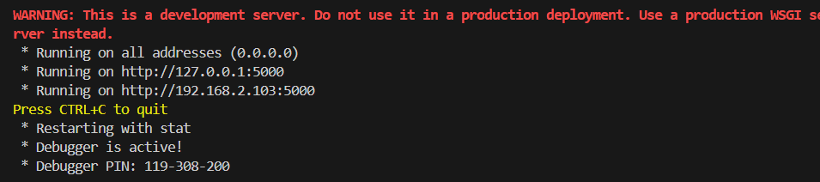

**8.3 Frontend Results:**

